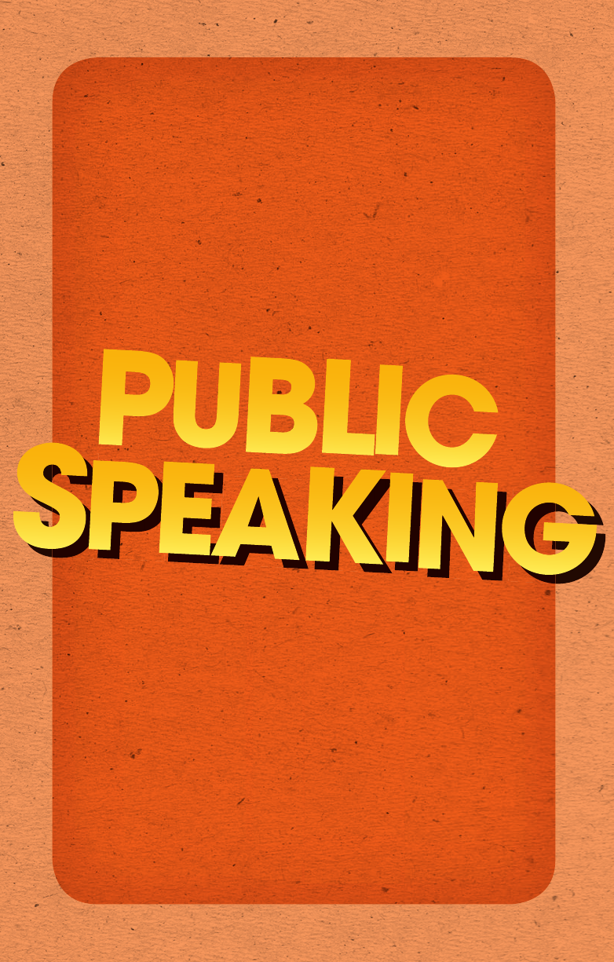

Contents

CONTENTS

viii

Part 3 Freshness

Create memorable public speaking experiences with creative

content.

6 Wonderful words and vibrant visuals 111

7 Ingenious interactivity 131

Part 4 Balance

Develop structures that are powerful and aid your memory.

8 The balancing act of structure 155

Part 5 Fearlessness

9

Understanding fear 189

10 Tools for developing fearlessness 203

Part 6 Authenticity

11

It ends with authenticity 227

The road ahead 239

Appendix 1 Public Speaking Ingredients List 241

Appendix 2 The Um Game 243

Appendix 3 Wonderful Words Bingo 245

Appendix 4 Design your stage persona 246

Appendix 5 Further resources 247

About the author

Sarah Lloyd-Hughes, founder of Ginger Training & Coaching,

is an experienced, energetic and empowering speaker, coach and

writer who works with individuals to support them in reaching

their potential. She has taught thousands of people of all ages

across three continents. Ranging from professionals in India’s

largest IT company, to young people in inner-city London, Sarah

builds confidence and inspiration in her audiences, whatever

their experience levels.

Sarah’s much-lauded workshops are bursting with fun, practical

and extremely powerful ways to improve your public speaking.

These days she focuses on working with professionals wishing

to become key people of influence in their field. She challenges

and supports them on the journey to become passionate,

authentic and inspiring speakers.

A practising Buddhist, Sarah suffers from a lifelong obsession

with happiness. Her personal passions include helping people

‘live life outside the box’, watching sunrise and eating cake

whilst it’s still warm.

For more information, please visit www.gingerpublicspeaking.com.

This book has been years in the making, but just a few intense

months in the writing. It’s not possible to count all the kind

words, snippets of advice and gentle shoves that have contributed

to its creation – thank you to all who provided them. But for rea-

sons of practicality, I’d like to turn the spotlight on some of the

contributors who have meant the most to me during this time.

My thanks must start at the beginning of my public speaking

journey with the tremendous organisation that is AIESEC UK.

Thank you for giving me that gut-wrenching experience of my

very first speech. To this day, you continue to give young people

outstanding opportunities to learn and grow.

Thanks to all of the experts who have contributed their time and

wisdom to this project: thank you to the countless wonderful

people who have helped me start my company, Ginger Training

& Coaching, without whom I wouldn’t be living my dream. My

clients and fellow coaches and speakers are a constant source of

learning and inspiration. James, Mara, Joel – thank you for giving

me the confidence to believe that my silly little doodles (featured

in this book) were worthy of public viewing.

My advisors, particularly Tom Butler-Bowden, Taz Miah and

Adam Penny – thanks for your intelligent and sensible words

and encouragement.

Jacqueline Burns of the Expert Agency, my wise and feisty agent

– thank you so much for making all of this happen.

Acknowledgements

x

ACKNOWLEDGEMENTS

xi

To my wonderful teachers who guide my desire to be beneficial

in the world – a heartfelt thank you.

A final group, who perhaps should have been first. Thank you to

my core of support as a coach, writer and human being – my ever-

supportive mum, dad and brother, Lyndsay, Richard and James,

for giving me so much self-confidence over the years. And thank

you to my darling Lukasz for putting up with me and being my

cheerleader when my head was stuck in a laptop for weeks on end.

To you, the reader, thanks for stopping by and I hope you ben-

efit immensely from these words and ideas.

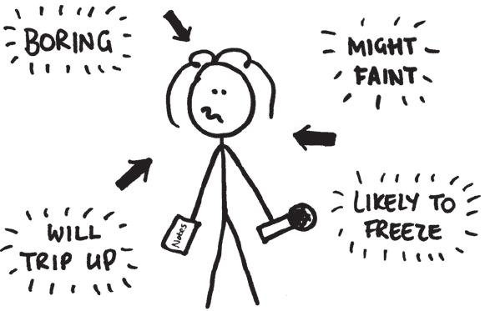

xii

Imagine you’ve just finished an important piece of public speak-

ing. It went better than you could have ever dreamed. Your

audience are beaming at you and you know that you hit the nail

on the head. Everyone in the room leaves feeling more knowl-

edgeable, inspired and ready for action.

This is closer to reality than you might think.

Yet, if you feel anything like I did when I first started speaking,

it will seem like miles off. I remember watching those ‘natural

born public speakers’ – people who just appear to leap up on

stage and say the right thing at the right time. It seemed to me

like they had a magic gene that allowed them to razzle dazzle

their audience with their intelligence, humour and charm. And

then when I thought of myself speaking, I felt like I was sur-

rounded by neon lights telling everyone just how terrible I was.

Introduction

INTRODUCTION

xiii

It’s easy to believe that you’re the only one who’s ever felt

intimidated by public speaking. It’s easy to focus on all those

speakers who seem effortlessly to impress. And it’s easy to

silently protest, ‘But I don’t have anything to say’, or ‘Why

would anyone listen to me?’ or ‘I just can’t do it!’ But you’re not

the first – or the last – public speaker to have those worries.

Beyond all proportion, public speaking is quoted as one of the

most feared activities in the modern world. As Jerry Seinfeld

famously quipped, ‘to the average person, if you go to a funeral,

you’re better off in the casket than doing the eulogy.’

Although we hold a myth that in public speaking you either ‘have

it or you don’t’, there’s really no such thing as a natural born public

speaker … just as there’s no such thing as a natural born judo

master, chess champion, accountant or any other expert.

The secret is that those ‘naturally masterful’ speakers have put

in an enormous amount of time and positive effort to get where

they are. They started where you are and they’ve battled their

own fears, they’ve scratched their heads about what to speak

about and they’ve pushed themselves beyond what they thought

possible. The results can knock the socks off an audience.

So there’s no reason why you can’t do the same.

In fact, anyone who can carry a conversation can be a bril-

liant public speaker. How can I be so sure? Because I’ve come

through it myself.

When I stepped out to deliver my first ever public speech, it was

with the aim of convincing 200 people I should be chosen for my

then dream job. It was a gut-wrenching experience, but I did it

because I cared more about the dream job than my sweaty palms,

my dry throat and my jelly legs. As I walked through the crowd to

the stage, I had no idea whether a single word would come out.

Yet these days, people say these sorts of things about my speaking:

Sarah is outstanding on stage. She’s riotously fun, totally engaging,

experienced and inspiring.



HOW TO BE BRILLIANT AT PUBLIC SPEAKING

xivxiv

Inspiring, passionate – watching Sarah in action is an affirming and

empowering experience.

Sarah is a fantastic presenter and teacher. Watch her, learn from

her and your public speaking will benefit.

How is such a difference possible if good speakers are born that

way? It wasn’t that (distinctly average) three-minute speech that

revolutionised my public speaking, although I did get the job.

Over time I developed techniques to get over the parts of public

speaking that I found difficult. I learned how to tame my nerves,

the best way to structure what I was saying, how to create an on-

stage character that my audience enjoyed, and so on.

I learned that there are three secrets of public speaking:

Let’s look at each of these principles in turn.

Public speaking secret 1: Anyone can learn to

speak in public

You can never predict who the great public speakers in a room

are, so I’ve stopped trying. I’ve seen shy introverts step onto

stage and blow everyone away with powerful words and I’ve

seen bouncy extroverts mumble and splutter until nobody in the

audience is left listening. Public speaking is not about your per-

sonality, it’s a skill that we can all learn.

Public speaking secret 1:

Anyone can learn to speak in public.

Public speaking secret 2:

Public speaking is an art, not a science.

Public speaking secret 3:

You already have everything you need to be a brilliant speaker.



INTRODUCTION

xv

The process of learning to speak in public is exactly the same

as any other learning process. It will happen naturally, so long

as you’re willing to be brave and try something different. The

key with public speaking is not to excuse yourself from it simply

because you’re nervous. Nerves are normal. Instead, progress

little by little by stepping onto the Learning Pathway:

1. Blissfully Unaware: Most speak-

ers who don’t look for help are

completely unaware of what they

don’t know. They’re satisfied with

their own performance, but from

the audience’s perspective they

make lots of embarrassing mis-

takes because they don’t have the

skills to speak well.

2. Rude Awakening: As you read

this book you may start to notice

what you do that isn’t as good

as it could be. You see the gap

between your abilities and where

you’d like them to be. It can be

difficult to hear, but the Rude

Awakening is crucial to help

you progress. If you don’t have a

single Rude Awakening during

this book, then either you’re a

perfect speaker, or you haven’t

been honest with yourself.

3.

Awkward Ability: Then, as you

pick up some techniques, you’ll

start to put them into practice.

This phase is like learning to drive

– you’re changing the gears, but

you have to think about it to get

it right. You will see that you’re

improving, but you may feel rather

self-conscious in the process.



HOW TO BE BRILLIANT AT PUBLIC SPEAKING

xvi

4. Absorbed Expertise: With time

and practice a new behaviour will

become a natural part of your

public speaking that you’re no

longer aware of. It feels great to

perform like an expert without

even realising it. Then it’s time to

pick the next bit of your perform-

ance to work on.

Anyone who continues along the learning pathway for long

enough and follows the techniques outlined in this book will

become not just a competent speaker, but a brilliant speaker.

The difference between those who make it and those who

stop half-way is their reaction during the Rude Awakening

and Awkward Ability phases. At these stages your confidence

can take a dip as you realise you have work to do to improve

your public speaking. It’s by pushing through these difficult

moments that you’ll learn how to inspire others.

Public speaking secret 2: Public speaking is

an art, not a science

A lot of the information we are fed as nervous or improving

public speakers is about what we should and shouldn’t be doing.

Often experienced speakers share their anecdotes about what

has worked for them and present them as a fact – ‘Copy me and

you’ll be a successful speaker.’ This makes it seem like there is a

science to speaking well.

In my experience, this is misleading for two reasons. First,

remembering all of the rules of what you should and shouldn’t

be doing makes you more nervous, rather than less. Second, if

you’re trying to mimic someone else’s performance, you won’t

come across as true to yourself. Just as Van Gogh would never

have reached his iconic status by copying Michelangelo’s paint-

ing style, you and your audience will both feel strange if you

copy another speaker.